SQL Performance troubleshooting guide: A walk through

This article gives a high-level view of isolating SQL Performance issues and logical approach to troubleshoot them.

SQL Server performance issues can be broadly categorized as:

* Overall Server slowness
* Specific query slowness

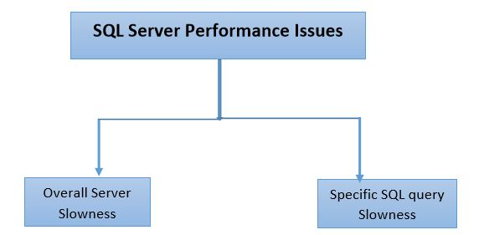

If SQL Server overall performance is slow, then we can categorize the issues as below: If SQL Server overall performance is slow, then we can categorize the issues as below:

* CPU/High Memory bottleneck
* IO Bottleneck
* Blocking
* Network bottleneck
* Latch Waits
* SQL Configuration issues
* Capacity limitation
* SQL/Windows known issues

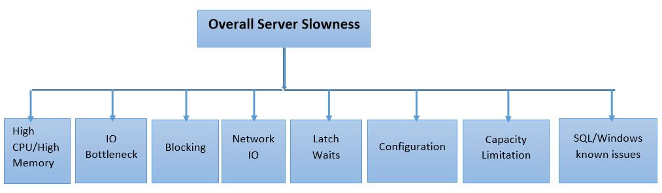

If a specific query is slow, then then the threads executing the query is either in one of the following states:

* Executing/Running
* Waiting

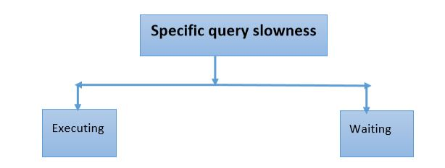

If the query is in executing state and the query execution is slow, the issues can be because of:

* Stale statistics
* High Index/Heap fragmentation
* Bad SQL Execution Plan
* Optimizer timeout
* Long compilations

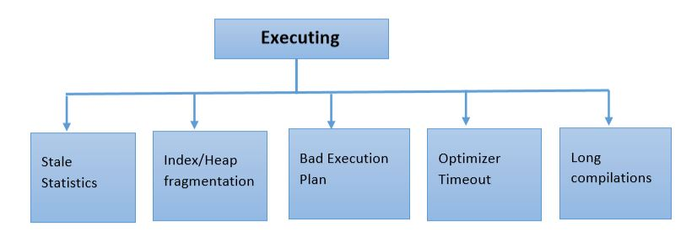

If the query is in waiting state and the query execution is slow, the issues can be because of:

* IO Bottleneck (PAGE IO Latch/Writelog)
* Blocking
* Network IO/Client Fetch
* Latch Waits
* Resource Semaphore waits

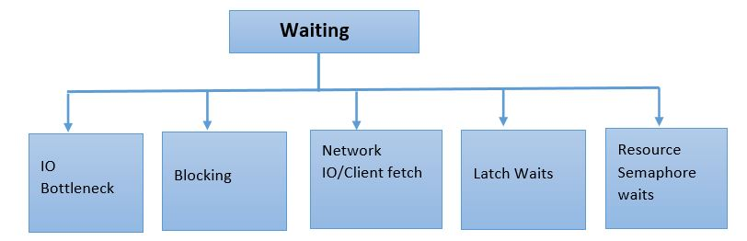

The above walk through is at very high level and refer it as a guide map while troubleshooting performance issues. Based on the bottleneck observed, issue can be drilled further by using dmv's or other troubleshooting tools.

**Written By**

**Don Castelino | Premier Field Engineer | Microsoft**